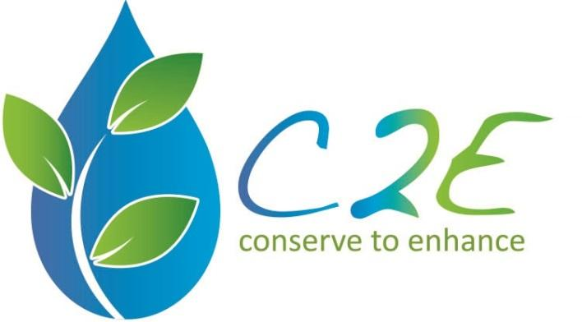
Application Instructions

This is a fillable Word document, which allows you to type in your responses. Save the completed application with your proposed project title as the file name.

Summary
Tucson C2E understands that maintenance is a question all green infrastructure (GI) projects in the region face. The goal of this agreement is to help Tucson C2E provide ongoing watershed enhancement by ensuring community commitment to site stewardship, providing resources needed, and implementing site maintenance. Tucson C2E has 9 small wash enhancement and GI project sites in need of varying levels of maintenance. Tucson C2E is looking for an organization that is qualified to maintain and enhance sites and refresh community engagement over approximately one year.

Tucson C2E is awarding one contract with an $8,000 maximum for the following scope of work and it will last 12 months, beginning summer of 2018.

Requirements for 2018 Projects

The Scope of Work is divided into three tasks for quote. Please submit a separate price for each task.

1. Contact Site Leads:
  - Site leads are community group leads that were past grant project recipients.
- Collection information from site contacts about observations of site needs.
- Visit all nine sites to confirm Appendix A observations and allow for additional recommendations per Task 2G.
- Share and gather feedback from site leads on the usefulness or gaps in C2E’s draft maintenance handbook.
- Coordinate with site leads to organize training and volunteer days to select days for maintenance events and together. All site contacts should be included in training even if they don’t require maintenance currently.
- Conduct outreach to promote events (work in coordination with Site leads and with Tucson C2E outreach committee).
- Optional: Recruit adoption group for long-term connection at current or additional sites, as needed.

2. Tucson C2E Project Site Maintenance Work, Volunteer Coordination and Community Training
- Address site needs per Appendix A. Your organization may add additional recommendations and utilize input from site leads (as described in #1).
  - Include permit costs, equipment and the purchase of necessary materials, such as mulch, plants and rock.
- Promote and conduct trainings with site leads (such as pruning, sediment trap improvements, or other trouble shooting). Invite larger Tucson C2E community involvement.
  - May conduct for multiple neighborhoods at once.
- Lead maintenance volunteer days (coordinate with Tucson C2E outreach committee, and project site leads to organize events where feasible) with neighbors and additional volunteers, as needed, and promote.
- Reporting: Communicate work days and progress with Tucson C2E Advisors and our newsletters/social media, take photos of people in action, write up results in summary report. Attendance is required at monthly Advisory Council meetings. Interim reports of accomplishments are required with each invoice or quarterly, whichever is more frequent.
- Take before, during and after pictures of all sites with focus on challenges addressed, to add to aid long term monitoring and for potential use in C2E maintenance handbook.
- Optional: Tucson C2E prefers community-based volunteers for maintenance but utilizing professionals may be necessary for some sites, such as for re-design, heavy equipment, or lack of voluntary site leads.

3. Provide Professional Advisement
- Review and provide your professional recommendations for C2E’s maintenance handbook drafts for community stewards of green infrastructure sites.
  - Tucson C2E to provide current drafts including checklists for inspecting sites, issues to address, and tips for leading community events.
- Provide brief recommendations based on your lessons learned above to inform a long-term “Maintenance Plan” for Tucson C2E.
  - May include recommendation of frequency of on the ground efforts by professionals or volunteers and seasonal coordination or monitoring needs with sites.

Evaluation Criteria

- Experience and Qualifications of Team
Provide experience and qualifications of key team members including any certifications applicable to the scope of work. Identify team experience on similar projects and the extent of team involvement.
Familiarity with stormwater harvesting and native plants is essential.

- Price Proposal to Complete Scope of Work

Deadline: Applications are due by 06/8/18 at 3:00 PM.

Submit your completed application packet via email to Tucson@conserve2enhance.org. The Tucson C2E Advisory Council will evaluate the applications in early June. After C2E Advisory Council makes its selection, funded maintenance can begin as early as July 2018.

Company Name:

Contact Name:

Contact Phone:

Contact Email:

Experience and Qualification of Team:

Proposed Project Timeline:

1. Contact Site Leads Price:
Brief explanation of costs:

2. Tucson C2E Project Site Maintenance Work Price:
Brief explanation of costs:

3. Provide Professional Advisement Price:
Brief explanation of costs:

Discussion of Optional Elements:

Tucson C2E Agreement

If your project is awarded funding, you agree to the following.

- I accept all requirements in the Scope of Work.
- I accept full responsibility for any project costs that exceed those included in the price proposal.
- I will request to shift no more than 10% of my funding amongst the three Scope of Work tasks.
- I will complete the Scope of Work within the time-period proposed. I understand that if these goals are not achieved the grant funds may need to be forfeited.
- I will inform C2E at least two weeks in advance when volunteer/public events occur for work days so that a C2E liaison can attend to make an introduction. I will use the C2E logo on fliers and tag C2E if using Facebook.
- I will submit reports as outlined in the Scope of Work. Up to a 30% advance can be requested. Submit invoices to directly to Tucson@conserve2enhance.org. Payments are made after goods and services are delivered.
- I will submit a final invoices and report once all work is completed.

By typing my name below, I acknowledge and agree to the conditions above.

Project Manager:
Date:

Executive Director:
Date:

